Maroubra Seals Snooker app review
10 September 2026 | Public and organiser flows | Desktop and 390 px phone view
The core competition flow works. Prioritise safer result entry, consistent updates and making live matches easier to find.

1 UI improvements
High | Require explicit result choices Complete preselects the first player as winner and Buys back. Leave both choices blank and enable Save only after a decision. Add a short result summary before saving.
High | When a match is being updated, do not lock all the matches only lock the one being updated so users can click on other matches to complete it in parralell
High | Prevent stale bracket updates After changing Player 3’s win to Player 4 and declining re-entry, Player 4 briefly remained both a round-two winner and a round-one buy-back. Reload cleared it. Ensure older refreshes cannot replace newer saved state.
High | Put live play first on phones Round-two waiting cards appear above the active round-one match. Default to Playing now, Up next and Results; offer the full draw separately. Add Find my match and table assignment.
Medium | Clarify public information Replace the run-on player/rating text with searchable rows and labelled handicaps. The empty page needs a useful next-night message. Move the floating Netlify badge out of the content area; it overlaps mobile cards.

2 Design improvements
Keep the club badge and navy identity. Use felt green for live play, neutral completed cards and amber waiting states. Reserve red for errors or destructive actions. Increase phone text and touch targets; shorten repeated handicap explanations.
Change the main page to look like this: without changing the functionality:
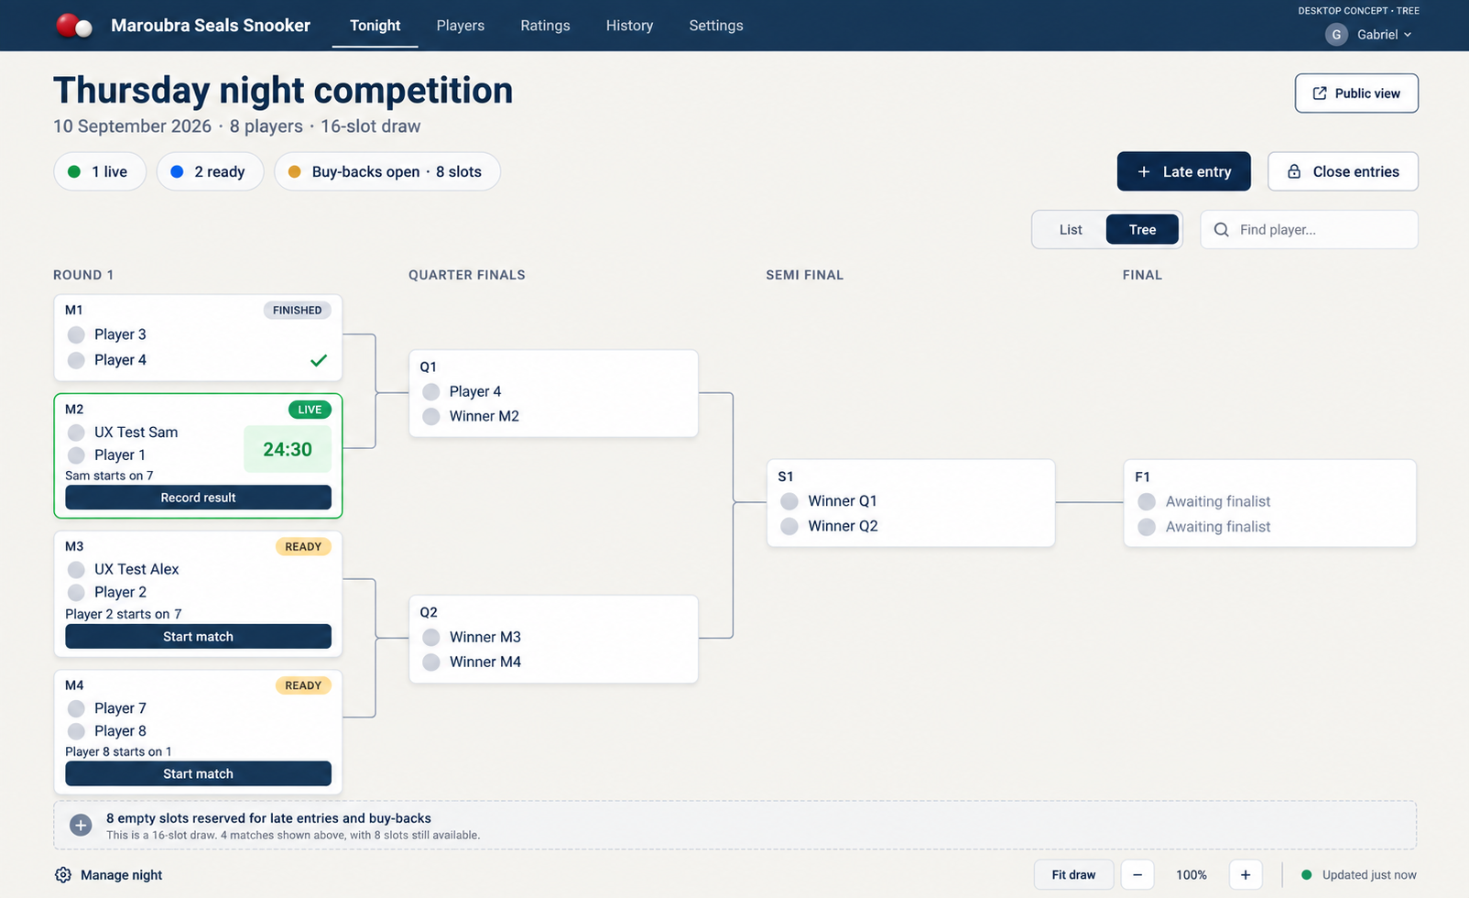

Actual mobile screen
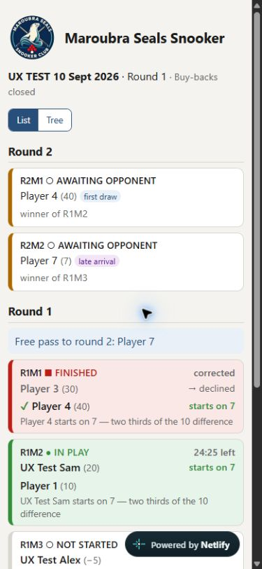
Observed: waiting cards lead the page; the floating badge overlaps the lower match card.

Proposed public and organiser screens
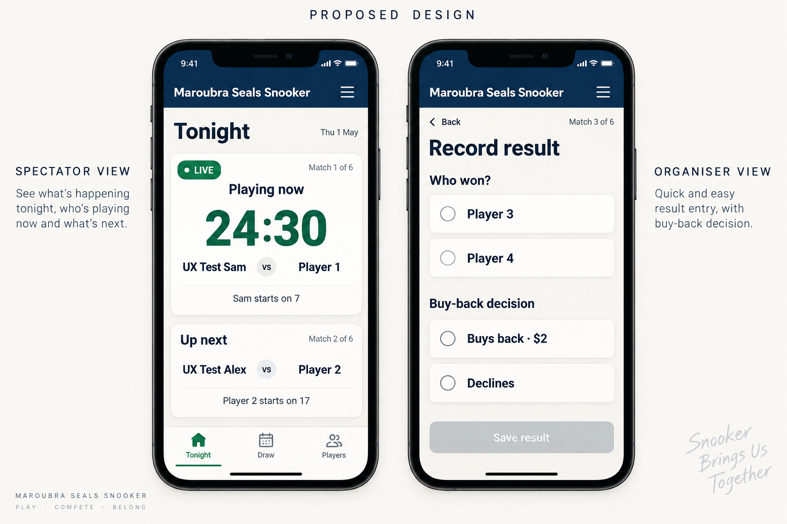
AI-generated design concept, not the live app. Use the hierarchy and explicit choices; retain the real club badge and actual competition date. Keep photography off the live scoring screen.

